**Description Rotations**

1. Leg Rotation about z

The maneuver is performed as follows:

1. From the desired neutral position, move the limbs so that the arms are next to the body and the legs are at an angle from the body’s z-axis as shown.

2. The legs are then rotated about the offset z, such that one leg is 180 degrees out of phase with the other, until the desired net rotation is obtained.

3. The limbs are returned to the chosen neutral position.

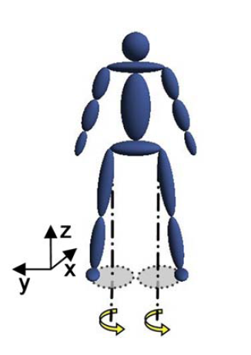

A positive rotary motion of the legs about z will yield a negative rotation of the body, while a negative rotary motion of the legs will yield a positive rotation of the body. The rotation with the arms is similar to that performed by the legs.

1. Arm Rotation about z

This maneuver is performed as follows:

1. From the desired neutral position, move the limbs such that the arms inclined from z. The legs can be outstretched or tucked.

2. The arms are rotated about the offset z in the same direction until the desired net rotation is obtained.

3. The limbs are returned to the chosen neutral position. Just as for the legs, a positive rotary motion of the arms yields a negative rotary motion of the body. This rotation will be explored with the arms both in-phase and out-of-phase. The final rotation that will be examined is a four-part limb manipulation motion originally developed by Kulwicki et al.

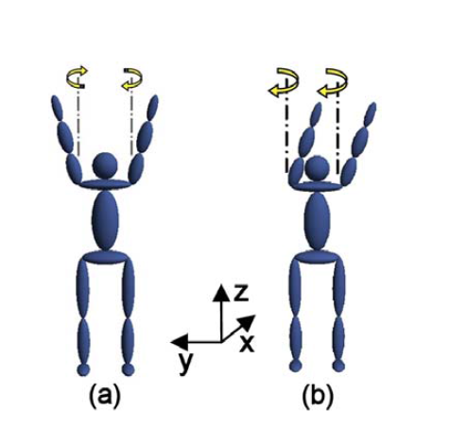

1. Limb manipulation Rotation around z

The maneuver is performed as follows:

1. In the initial stage, the body is straight, arms down, and legs spread to the side.

2. The torso is twisted about the axis of intended rotation.

3. The moment of inertia is increased at the top of the body by spreading the arms and decreased in the lower part of the body by closing the legs.

4. In the final stage, the body is untwisted at the waist and the arms are lowered. These steps can be repeated until the desired net rotation is achieved.

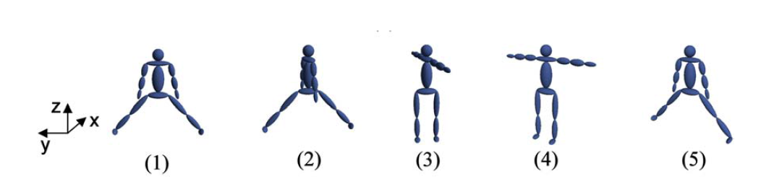

By modifying the ratio of the inertia of the upper body with respect to the lower body between the twist and untwist, a net body rotation is possible. While this maneuver does not have significant off-axis rotations, its complexity increases due to the increased number of steps.